Renishaw Primary School

Respect Pride School



Hague Lane
Renishaw
S21 3UR
Tel: 01246 432366
Email: info@renishaw.derbyshire.sch.uk
www.renishaw.derbyshire.sch.uk

Head Teacher: Mr Simon Fuller
Assistant Headteacher: Mrs Kelly Dixon
School Business Manager: Miss Jodie Baker
Chair of Governors: Mr Brian Ridgway

Behaviour Policy

RENISHAW PRIMARY SCHOOL

BEHAVIOUR POLICY

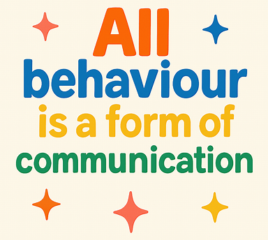

Introduction & Purpose
Renishaw Primary School is committed to creating a safe, inclusive and aspirational environment where all pupils can thrive academically, socially and emotionally. We believe that positive behaviour is essential for effective teaching and learning, and that all members of our community share responsibility for maintaining high standards.

Renishaw Primary is an ambitious school which strives for the highest standards of teaching, learning and behaviour in an environment that nurtures and supports every child and adult as an individual; where their efforts are respected and celebrated. Our core school values, and use of Restorative Approaches underpin everything we do at Renishaw Primary School.

Aims
Our aims are to work together, to:

a) promote high standards of teaching, learning and behaviour;
b) ensure that everyone achieves their full potential irrespective of race, gender or physical disability.
c) provide a happy, supportive and safe environment.

This policy:
- sets out the expectations for behaviour and conduct
- outlines the systems for promoting positive behaviour
- details the procedures for responding to incidents
- explains how we prevent and address bullying
- ensures compliance with statutory guidance
- reflects our restorative ethos and inclusive values

This policy applies to:
- all pupils
- all staff (teaching and non‑teaching)
- volunteers
- visitors
- behaviour on and off the school site

Legal & Statutory Framework
This policy is written with reference to the following statutory and non‑statutory guidance:
- Behaviour in Schools (DfE, 2022)
- Suspension and Permanent Exclusion (DfE, 2023)
- Keeping Children Safe in Education (DfE, 2024)
- Education and Inspections Act (2006)
- Education Act (2011)
- Searching, Screening and Confiscation (DfE, 2023)
- Use of Reasonable Force (DfE, 2013)
- Equality Act (2010)
- Prevent Duty (Counter‑Terrorism and Security Act, 2015)
- SEND Code of Practice (2015)
- Derbyshire County Council Behaviour & Inclusion Guidance

The Headteacher has a statutory duty to determine measures to promote good behaviour and discipline.

School Values & Behaviour Principles (“The Renishaw Way”)
Our behaviour culture is rooted in our core values:

Respect:
We treat others with kindness, dignity and fairness. We value differences and listen to each other. We are determined to develop our children’s respect and tolerance for other’s opinions and beliefs. We believe that our school community should be polite, open minded members of society and we aim to equip them with a range of strategies for developing respect for themselves and others.

Pride
We take pride in our work, our school and our achievements. We aim to encourage and nurture our children’s aspirations and show them, through a range of experiences, the possibilities available for their future. We have high expectations for each child and actively encourage them to fulfil their potential.

Success
We celebrate effort, perseverance and curiosity. We encourage children to have a positive attitude to their work and life in general and view it as our duty to prepare children for the ever- changing world we live in. We feel this comes from exposing children to a wide variety of situations that challenge their ideas, whilst providing a safe place for them to develop their ability to adapt to different situations, learn from their mistakes and embrace challenges.

These values are explicitly taught through:
- Assemblies
- RSHE lessons
- No Outsiders inclusion curriculum
- classroom routines
- restorative conversations
- pupil leadership roles

Our Approach

We recognise that the quality of teaching and learning in each lesson directly affects the behaviour of pupils. Managing behaviour is not just about responding to inappropriate behaviour; it is about creating the conditions that encourage positive behaviour. We recognise that all behaviour is a form of communication and that continued disruptive behaviour may be due to an unmet need. A child’s poor behaviour is often a result of difficulties they are experiencing. If the causes of the behaviour are identified and appropriate support is provided, the behaviour can be turned around and the barriers to learning removed. We encourage good behaviour through a mixture of high expectations, clear, consistent procedures and an ethos which fosters discipline and mutual respect between pupils, and between staff and pupils.

Roles and Responsibilities

The promotion of positive behaviour is the responsibility of the school community as a whole. The Governing Body, Headteacher and staff are responsible for ensuring that all aspects of the school’s Behaviour Procedures and its application, promote equality for all students.

The roles include:
- The Governing Body defining the principles underlying the school’s Behaviour Policy.
- The Head teacher and Senior Leadership Team in framing and establishing an environment that encourage positive behaviour and regular attendance.
- All adults in ensuring that the policy is consistently and fairly applied and that students are taught how to behave well.
- Students who are able to behave in a way that promotes the learning of all in the community.
- Parents and carers in taking responsibility for their child’s behaviour inside and outside the school to maintain high standards of behaviour. This includes supporting the school in imposing sanctions where necessary.
- Parents are in partnership with the school to promote good behaviour. A reminder of our behaviour expectations is included in our home/school agreement and on our school website.

Expectations of Adults

- Treat each other with respect at all times, therefore providing a positive role model for the children and each other.
- Provide encouragement and stimulation to all pupils.
- Treat all children fairly and apply this policy in a consistent way.
- Ensure children are aware of the whole school expectations.
- Teach, through the school curriculum, values and attitudes as well as knowledge and skills, in order to promote responsible behaviour, self-discipline and respect for self, others and the world around us.

Teaching Behaviour & Emotional Regulation
Behaviour is taught explicitly, just like any other curriculum area.

Zones of Regulation:  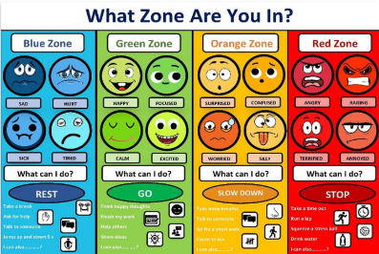 | All pupils learn to:  - identify their emotional state  - use strategies to regulate  - communicate their needs  - recognise triggers  Zones displays are present in every classroom.
Calm Corners:  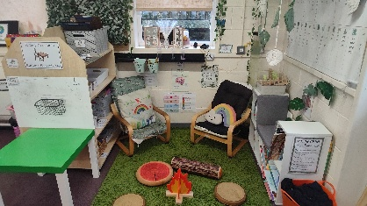 | Every classroom has a calm corner equipped with:  - sensory tools  - visuals  - timers  - breathing prompts  - emotion cards  Calm corners are not a sanction; they are a regulation tool.
Co-Regulation:   | Staff support pupils to regulate through:  - modelling calm behaviour  - offering choices  - using grounding techniques  - providing space and time
  No Outsiders: | The No Outsiders curriculum teaches children that everyone is welcome and valued. Each half-term, every class from Reception to Year 6 explores a picture book that promotes equality, respect and understanding of difference. These lessons help pupils develop empathy, recognise emotions and understand how their actions affect others. By discussing real-life scenarios and practising inclusive language, children learn to regulate their feelings, resolve conflict respectfully and make positive behaviour choices. No Outsiders strengthens our restorative approach and reinforces “The Renishaw Way” across the whole school.

Curriculum Links
Behaviour and emotional regulation are taught through:
- RSHE curriculum
- PSHE lessons
- No Outsiders programme
- Assemblies
- Circle time

Restorative Justice
As a school we embrace restorative approaches which aim to build the school community and to repair and strengthen relationships within it. These approaches foster an awareness of how others have been affected by inappropriate behaviour. This is done by actively engaging participants in a process allowing participators to make amends for the harm caused. Restorative Approaches acknowledges the intrinsic worth of the person and their potential contribution to the school community.

Restorative Approaches aim to:
- improve behaviour and attitudes;
- provide explicit tools within a defined framework to challenge unacceptable behaviour, resolve conflict and repair harm;
- improve relationships; establish rights, accountabilities, and responsibilities to the community;
- provide a safe philosophical basis for staff pupils and parents to share ideas and discuss issues.

How we use Restorative Justice

All staff follow the steps outlined below to resolve a conflict. It is imperative that all parties involved in the process are in the correct state of mind (calm) prior to beginning with the first part- ‘what happened.’ This must be addressed using calming techniques and support from an adult if the child cannot yet self- regulate.

Throughout the process, the emphasis is on recognising and owning feelings, understanding the repercussions of what happened and for the child to realise what to do to make things right.
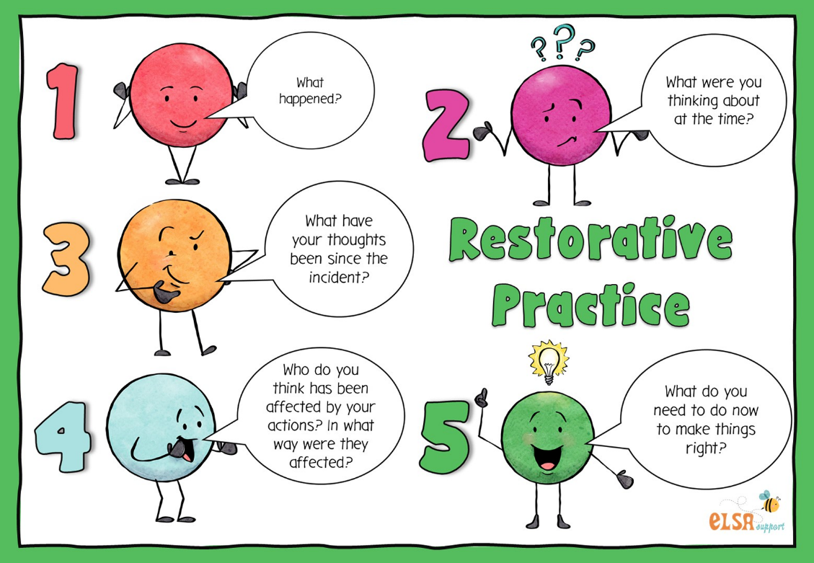

Restorative Approaches
Restorative practice is central to our behaviour culture.
Aims:   | - repair harm  - rebuild relationships  - promote accountability  - develop empathy  - reintegrate pupils positively
Restorative Questions:   | - What happened?  - What were you thinking/feeling?  - Who has been affected?  - What needs to happen to put things right?  - How can we do things differently next time?
When is it used:  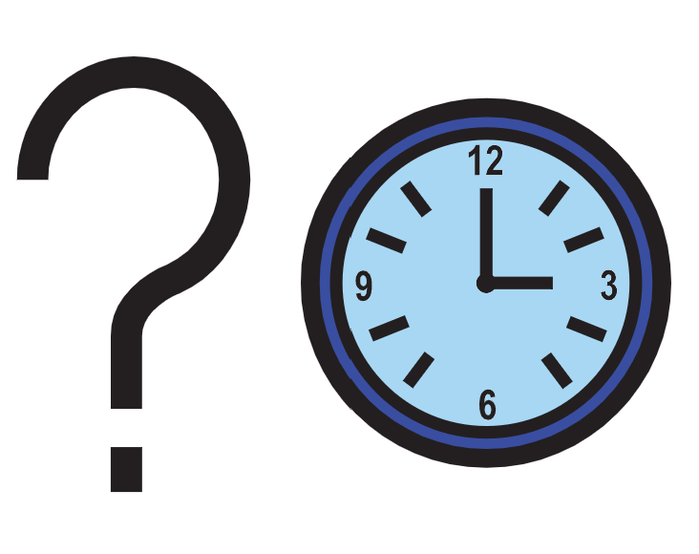 | - after conflict  - following incidents of unkindness  - after disruption  - during reintegration meetings

Restorative conversations only occur once all parties are calm.

Our School Rules
All members of our school community have a responsibility to respect the rights of others and follow our school rules. At Renishaw Primary School, we follow these golden rules:

- We are gentle. We don’t hurt others.
- We are kind and helpful. We don’t hurt anybody’s feelings.
- We listen. We don’t interrupt.
- We are honest. We don’t cover up the truth.
- We work hard. We don’t waste our own or others’ time.
-We look after property. We don’t waste or damage things.

Positive Behaviour
It is our belief that fostering a community of mutual respect among staff and pupils sets behaviour expectations high and motivates children to do the right thing instinctively. We recognise that mistakes will be made from time to time and that is when we employ a restorative approach to understanding the reasoning behind a display of undesired behaviour.

We have taken the decision to reward effort rather than compliance to allow every child a chance at success and ensure equity and inclusion.

The efforts we reward focus in these areas:
- focus and involvement in aspects of school life
- energy
- fascination and curiosity
- pride
- meeting their own challenges

In most instances, this will take the form of specific, verbal praise in the moment. We believe this has the most value to the child and helps to keep children motivated and enthusiastic about learning. We will also encourage children to share their success with a member of staff of their choosing.

Positive rewards could also take the form of:

- Class Dojo points awarded to a group or an individual.
- a message of celebration directly to the parent or carer verbally or via ClassDojo.
- a phone call home.
- a head teacher’s award certificate.
- sharing work the children are proud of
- proud wall or gallery display in class

Behaviour Pathway: “Choice, Chance, Change”
A consistent, transparent and fair behaviour pathway is essential to ensuring that all pupils understand expectations and experience predictable adult responses. At Renishaw Primary School, the “Choice, Chance, Change” pathway provides a structured, step-by-step process that supports pupils to recognise their behaviour, regulate their emotions and make positive choices. This approach ensures that behaviour is addressed promptly, calmly and proportionately, while maintaining a focus on teaching, repairing and restoring relationships. The pathway is used by all staff across the school to provide clarity, reduce escalation, and ensure that pupils are given clear opportunities to reflect and change their behaviour before further action is taken. It also ensures that incidents are recorded accurately, that support is provided where needed, and that responses remain consistent, equitable and aligned with our restorative ethos and statutory duties.

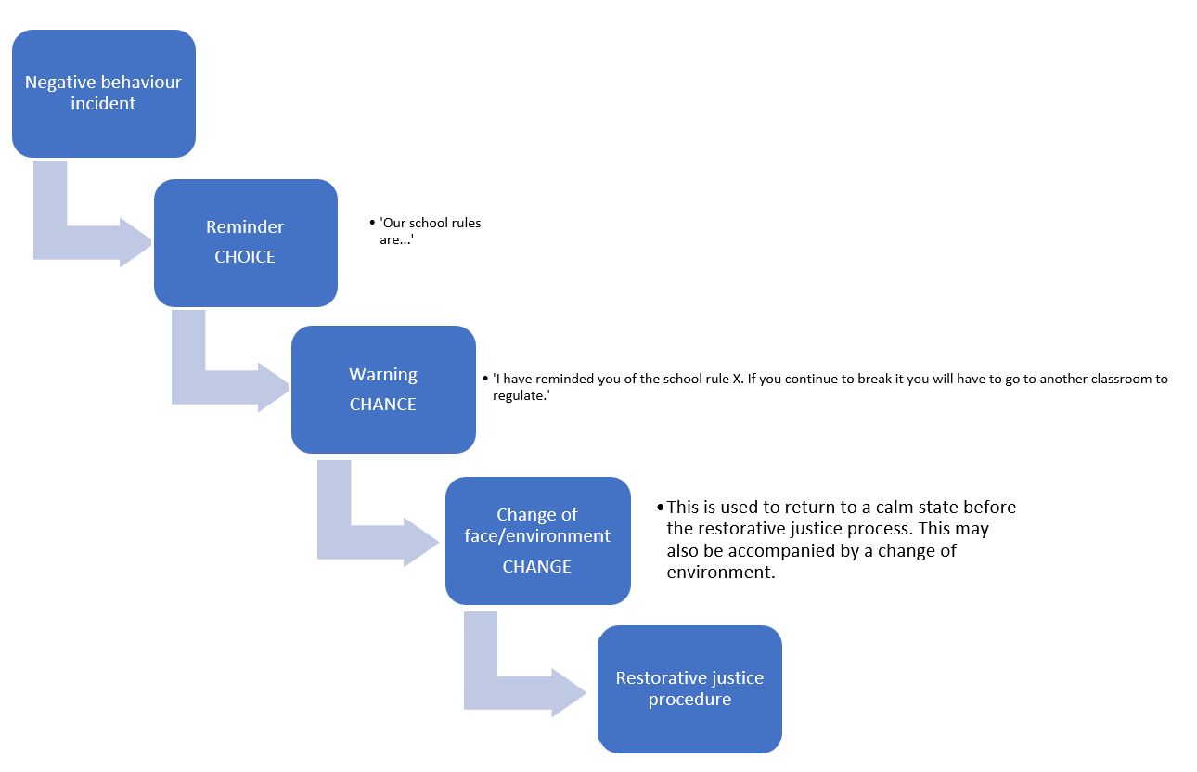

If the child persists with the negative behaviour, a warning must then be issued with an understanding that the child will be asked to go to the ‘calm corner’ to regulate their behaviour. This may be assisted by an adult to co-regulate.

If the child still persists, then the child will be asked to regulate themselves. If they cannot do that, another adult (change of face) will be called upon to help that child regulate. This is called co-regulation. It will be at this point that the adult reports the behaviour concern on our CPOMS system. This is systematically reviewed and actioned by our senior leadership team.

Once the child and original adult are back in the calm state, the restorative justice process can begin.

Recording
All medium-level and above incidents are recorded on CPOMS. Minor incidents can be recorded on individual behaviour logs held within the classroom.

Sanctions framework
A clear, fair and proportionate sanctions framework is essential to maintaining a safe, orderly and purposeful learning environment. At Renishaw Primary School, sanctions are used not as punishment, but as structured responses that help pupils understand the impact of their behaviour, take responsibility for their actions and re-engage positively with learning.

Sanctions are always applied with regard to the pupil’s age, developmental stage, SEND profile, safeguarding context and any other relevant vulnerabilities, ensuring compliance with the Equality Act 2010 and the SEND Code of Practice. All staff follow the same graduated approach so that pupils experience consistency, predictability and fairness across the school.

Importantly, when a pupil loses time from break or lunchtime, this time is always used for restorative conversation and reflection, enabling the child to repair relationships, understand the consequences of their actions and return to learning ready to succeed. Every sanction is accompanied by opportunities for reflection and restoration, and all medium-level or above incidents are recorded on CPOMS to ensure transparency, monitoring and appropriate follow-up by the Senior Leadership Team.

Sanctions are:
- proportionate
- fair
- consistent
- recorded appropriately
- adapted for SEND where needed
Minor incidents: | Medium-Level Incidents: | Serious Incidents: | Very serious incidents:
Examples:  - calling out  - off-task behaviour  - not following instructions  - low-level disruption | Examples:  - repeated low-level disruption  - rudeness  - verbal unkindness  - refusal to follow instructions | Examples:  - aggression  - bullying  - theft  - damage to property  - leaving class without  permission | Examples:  - physical aggression towards staff  - bringing prohibited items  - serious bullying or harassment  - dangerous behaviour
Potential responses:  - reminder  - warning  - move seat  - brief loss of break  - restorative conversation | Potential responses:  - SLT involvement  - phone call home  - behaviour reflection sheet  - loss of break/lunchtime  - meeting with parents | Potential responses:  - SLT investigation  - behaviour plan  - internal exclusion  - fixed-term suspension | Potential responses:  - internal exclusion  - fixed-term suspension  - permanent exclusion  - police involvement  (if required)
Logged:  Low level individual behaviour logs | Logged:  Low level individual behaviour logs | Logged:  Low level individual behaviour logs | Logged:  Low level individual behaviour logs

Fixed Term Exclusions
In extremely rare circumstances where behaviour is either persistently negative (the child is not learning from their mistakes) or there is an extreme incident it may be necessary to issue a fixed term exclusion. A fixed term exclusion will follow the below procedures:

- LEA form outlining exclusion
- Letter to parents/carers/social worker outlining length of exclusion
- Written report to HT, class teacher and LM on the incidents leading to exclusion
- Inform any agencies working with pupil
- Inform EWO co-ordinator
- Copy to Chair of Governors and Director of Education – copy in child’s folder
- To liaise with class teacher to set work for the period of exclusion

Reintegration from Exclusion
The child must be brought back at 8.40 on the first day back at school. They must be brought back by the parents and meet with the headteacher (HT). A reintegration and support plan will be created with all parties and a review date set. We aim to repair situations with the same restorative justice principles.

Permanent Exclusions
- The HT exercises duty to permanently exclude when
- The safety of other pupils/adults can no longer be assured
- The pupil is continually affecting the education of others
- The school has exhausted all measures to try and improve the pupil’s behaviour
- The pupil has seriously breached the school’s behaviour policy
- The school will follow DFES guidance on permanently excluding pupils.

Teachers Statutory Authority
All staff at Renishaw Primary School have a shared responsibility to promote positive behaviour and maintain a safe, calm and purposeful learning environment. In line with Sections 90 and 91 of the Education and Inspections Act (2006), teachers and other paid staff with responsibility for pupils have the legal authority to address behaviour that does not meet school expectations, whether this occurs in school or during any school-organised activity.

This authority supports staff to uphold our values of Respect, Pride and Success, ensuring that pupils receive clear guidance, consistent boundaries and supportive interventions. Staff may address behaviour at any time when a pupil is:
- participating in a school-organised or school-related activity
- travelling to or from school
- wearing school uniform
- identifiable as a Renishaw pupil in the community

Staff may also respond to behaviour outside these circumstances if it:
- affects the safe and orderly running of the school
- poses a risk to another pupil or member of the public
- has the potential to impact the reputation of the school

Where appropriate, staff may use their legal authority to set consequences such as break or lunchtime reflection time. At Renishaw, this time is always used for restorative conversation, ensuring pupils understand the impact of their actions and can return to learning positively. Staff also have the legal power to issue detentions outside school hours; however, any action taken will always prioritise pupil safety, wellbeing and dignity, and will ensure pupils have access to food, drink and toilets.

Support for behaviour
Renishaw Primary School is committed to ensuring that all pupils receive the support they need to meet behaviour expectations and to thrive socially, emotionally and academically. We recognise that behaviour is often a form of communication and may indicate underlying emotional needs, developmental differences, safeguarding concerns or external pressures. For this reason, behaviour support is proactive, personalised and rooted in early identification. We do not wait for behaviour to escalate before offering help; instead, we use a graduated approach to ensure that pupils receive timely, appropriate and effective support.

Support for behaviour is coordinated through our whole-school provision map, which outlines the full range of SEMH (Social, Emotional and Mental Health) interventions available in school. These interventions are evidence-informed, regularly reviewed and tailored to individual needs.
They may include:
- risk assessments
- Positive Behaviour plans
- Individual daily behaviour charts
- targeted small-group work
- soft starts
- adapted timetables
- 1:1 mentoring
- structured emotional literacy sessions
- sensory regulation programmes
- check-ins with a trusted adult
- personalised regulation strategies linked to the Zones of Regulation.

Where a pupil requires additional expertise beyond the school’s internal provision, we work collaboratively with a range of external agencies to ensure a joined-up, multi-agency response. These include:
- P4YP Early Help
- Educational Psychologists
- Social Care
- ISAS (Inclusion Support Advisory Service)
- Compass Changing Lives.

Referrals to external agencies are always made in partnership with parents and carers, and with the child’s voice central to the process. Multi-agency meetings are convened where appropriate to ensure that support is coordinated, consistent and aligned with wider family or safeguarding plans.

All behaviour support is recorded, monitored and reviewed through individual behaviour logs, CPOMS and regular meetings between class teachers, the SENCO and the Senior Leadership Team. Plans are adjusted as needed to ensure they remain effective and responsive. Our approach ensures that pupils are supported holistically, that barriers to learning are reduced, and that every child has the opportunity to succeed within a safe, nurturing and restorative school environment.

SEND, Vulnerable Pupils and Reasonable Adjustments
Renishaw Primary School is committed to ensuring that all pupils, including those with Special Educational Needs and Disabilities (SEND) and those identified as vulnerable, are supported to meet behaviour expectations in a fair, equitable and inclusive way. We recognise that behaviour is often a form of communication and may reflect underlying needs, developmental differences, trauma, safeguarding concerns or external pressures. In line with the Equality Act 2010, the SEND Code of Practice (2015) and our safeguarding duties, we make reasonable adjustments to ensure that pupils with additional needs are not disadvantaged by the application of this policy. Our approach is proactive, personalised and rooted in understanding the whole child. Staff are expected to consider individual needs, adapt their responses accordingly, and work collaboratively with families and external professionals to ensure that every child can succeed within a safe, nurturing and restorative environment.

Renishaw Primary School is committed to:
- ensuring that no pupil is excluded from opportunities due to their needs
- maintaining high expectations while providing appropriate support
- fostering a culture of belonging, safety and respect
- ensuring that all pupils can access learning and participate fully in school life

Principles for Supporting SEND and Vulnerable Pupils with behaviour
We are committed to:
- recognising that behaviour may be a communication of unmet need
- ensuring that pupils with SEND or vulnerabilities are not unfairly penalised
- making reasonable adjustments to expectations, routines and responses
- ensuring staff understand individual needs and recommended strategies
- using trauma-informed and attachment-aware approaches
- ensuring that pupils have access to trusted adults and safe spaces
- involving parents and carers at every stage
- ensuring that support is consistent, coordinated and regularly reviewed

To do this, we:

Use Reasonable Adjustments: | Reasonable adjustments may include:  - modified expectations for behaviour or communication  - additional processing time  - visual prompts, schedules or social stories  - access to sensory tools or sensory breaks  - use of calm corners or alternative regulation spaces  - adapted seating or classroom arrangements  - pre-teaching or rehearsal of routines  - reduced verbal demands  - alternative consequences that avoid escalation  - increased adult support during transitions or unstructured times  These adjustments are planned in collaboration with the SENCO,  class teacher, parents and, where appropriate, the pupil.
Use A Graduated Response: | Assess  - We follow the Assess–Plan–Do–Review cycle outlined in the  SEND Code of Practice.  - Identify underlying needs  - Gather information from staff, parents and the pupil  - Review CPOMS records and previous interventions  Plan  - Agree strategies and reasonable adjustments  - Identify adults responsible for support  - Set clear, achievable targets  Do  - Implement agreed strategies consistently  - Provide targeted SEMH interventions from the school provision  map  - Ensure regular check-ins with a key adult  Review  - Evaluate impact  - Adjust strategies as needed  - Involve external agencies if progress is limited.
Identify Vulnerable Pupils | We recognise that some pupils may be vulnerable due to:  - safeguarding concerns  - adverse childhood experiences (ACEs)  - trauma  - being looked-after or previously looked-after  - being a young carer  - family circumstances  - mental health needs  For these pupils, we ensure:  - a named key adult  - increased emotional check-ins  - personalised regulation strategies  - careful consideration of triggers  - close communication with parents and carers  - multi-agency involvement where appropriate
Utilise External Agency  Support | Where additional expertise is required, we work with:  - P4YP Early Help  - Educational Psychologists  - Social Care  - ISAS (Inclusion Support Advisory Service)  - Compass Changing Lives  - Health professionals (e.g., paediatricians, CAMHS)
Create personalised plans  (Risk assessments, Positive  Behaviour Plans and daily  behaviour charts) | Some pupils may require:  - Individual Behaviour Plans (IBPs)  - Pastoral Support Plans (PSPs)  - Positive Handling Plans  - Risk assessments for behaviour that may present safety  Concerns  These documents:  - outline triggers, strategies and agreed responses  - identify key adults  - include regulation strategies  - are shared with all relevant staff  - are reviewed regularly
Record and Monitor | All significant incidents involving SEND or vulnerable pupils are recorded on  CPOMS. SLT and the SENCO monitor:  - patterns of behaviour  - effectiveness of strategies  - impact of reasonable adjustments  - need for additional support or referral  This ensures that responses remain fair, consistent and aligned with statutory  duties.

Confiscation, Searching and Screening
Renishaw Primary School is committed to maintaining a safe, orderly and disruption-free learning environment. To achieve this, staff may need to confiscate items, or in some circumstances, conduct searches in line with statutory guidance. All actions taken under this section comply with the Education and Inspections Act 2006, the Education Act 2011, and the DfE guidance Searching, Screening and Confiscation (2023). Our approach prioritises pupil safety, dignity and wellbeing, and ensures that any intervention is reasonable, proportionate and clearly documented. Confiscation and searching are never used as punishment; they are used solely to prevent harm, maintain safety, and uphold the rights of all pupils to learn without disruption.

Staff may confiscate items when it is necessary to:
- prevent disruption to learning
- maintain safety
- protect the wellbeing of pupils
- uphold school rules
- prevent damage to property

Confiscation is always:
- reasonable in the circumstances
- proportionate to the concern
- recorded when appropriate
- communicated to parents when necessary

Items that may be confiscated include:
- items causing distraction (e.g., toys, gadgets)
- items used inappropriately (e.g., mobile phones used during lessons)
- items that pose a safety risk (e.g., sharp objects not required for learning)
- items prohibited by school rules (e.g., vapes, laser pens)

Confiscated items are stored safely and returned to the pupil or parent at an appropriate time, depending on the nature of the item and the circumstances of the incident.

Prohibited Items
The following items are prohibited by law and may be searched for without consent:
- knives or weapons
- alcohol
- illegal drugs
- stolen items
- tobacco, vapes or cigarette papers
- fireworks
- pornographic images
- any article that has been or is likely to be used to commit an offence
- any article that may cause personal injury or damage to property
These items will not be returned to pupils. They may be handed to the police or disposed of in line with statutory guidance.

Items Banned by the School
The school may also ban items that:
- disrupt learning
- undermine safety
- contradict the ethos of the school
Examples include:
- mobile phones used during the school day
- fidget items not recommended as part of a regulation plan
- inappropriate jewellery
- energy drinks
These items may be searched for with consent and confiscated if necessary.

Searching With Consent
A search with consent may be carried out by any member of staff.
Consent is considered given when a pupil:
- agrees verbally
- cooperates with turning out pockets
- allows a bag or coat to be checked
Staff will always:
- explain why the search is necessary
- conduct the search respectfully
- ensure another adult is present where possible
- avoid physical contact unless necessary for safety

Searching Without Consent
Searching without consent may only be carried out by:
- the Headteacher
- a member of the Senior Leadership Team authorised by the Headteacher
This applies only when searching for prohibited items listed in Section 13.2.

When conducting a search without consent, staff will:
- ensure the search is reasonable and proportionate
- ensure the pupil’s dignity is protected
- have another adult present wherever possible
- limit the search to outer clothing and possessions
- never require a pupil to remove clothing beyond outer layers (e.g., coat, jumper, shoes)

After a Search
Following any search (with or without consent):
- the pupil will be informed of the outcome
- parents will be contacted where appropriate
- items will be stored, returned, disposed of or handed to the police as required
- a record will be made on CPOMS for transparency and monitoring

If a prohibited item is found, the Headteacher will determine the appropriate next steps, which may include sanctions, safeguarding actions or police involvement.

Reasonable Force
Staff at Renishaw Primary School may use reasonable force if necessary in line with DfE ‘Use of Reasonable Force’ Guidelines 2013. The term ‘reasonable force’ covers a broad range of actions that involve a degree of physical contact with children. This force is usually used either to control or restrain. This can range from guiding a child to safety by the arm through to more extreme circumstances such as breaking up a fight or where a student needs to be restrained to prevent violence or injury.

‘Reasonable in the circumstances’ means using no more force than is needed.
Control means either passive physical contact, such as standing between children or blocking a child's path, or active physical contact such as leading a child by the arm out of a classroom.
Restraint means to hold back physically or to bring a child under control. It is typically used in more extreme circumstances, for example when two children are fighting and refuse to separate without physical intervention.

Staff should always try to avoid acting in a way that might cause injury, but in extreme cases it may not always be possible to avoid injuring the child. All members of school staff have a legal power to use reasonable force. This power applies to any member of staff at the school.

It can also apply to people whom the Headteacher has temporarily put in charge of children such as unpaid volunteers or parents accompanying students on a school organised visit.

When can reasonable force be used?
Reasonable force can be used to prevent children from hurting themselves or others, from damaging property, or from causing disorder and all of our staff members were specifically trained in restraint in 2024In a school, force is used for two main purposes – to control children or to restrain them. The decision on whether or not to physically intervene is down to the professional judgement of the staff member concerned and should always depend on the individual circumstances.

The following list is not exhaustive but provides some examples of situations where reasonable force can be used. (Section 93, Education and Inspections Act 2006) Schools can use reasonable force to:

- Remove disruptive children from the classroom where they have refused to follow an instruction to do so.
- Prevent a child behaving in a way that disrupts a school event or a school trip or visit.
- Prevent a child leaving the classroom/school building and grounds, where allowing the child to leave would risk their safety or lead to behaviour that disrupts the behaviour of others.
- Prevent a child from attacking a member of staff or another child, or stop a fight in the playground.
- Restrain a child at risk of harming themselves through physical outbursts.

Staff using force should do so in accordance with the Department for Education’s guidelines: ‘Use of Reasonable Force’. Staff do not require parental consent to apply reasonable force on a pupil, however, if a situation has arisen where it has been necessary to apply reasonable force the parents/carers of all involved will be informed. Staff should make reasonable adjustments to the use of reasonable force for disabled children and children with special educational needs (SEN).

Monitoring, Data & Quality Assurance
SLT monitors:
- CPOMS data
- behaviour trends
- bullying patterns
- attendance
- exclusions
- pupil voice
- parent voice

Associated Policies
- Safeguarding & Child Protection
- RSHE Policy
- SEND Policy
- Exclusions Policy
- Online Safety Policy
- Equality Duty Statement
- Safe Touch Policy

Associated Policies
Equal Opportunities
Anti-bullying policy
Safeguarding
Exclusion Policy
SEN policy
Safe touch policy

Signed __Brian Ridgway Chair of Governors

Approved by Governors _September 2025

Next Review: October 2026

Minute Number ___

Date approved by the Governing Body 17th October 2019
Minute No:____ 21/10.19d ______

Date to be reviewed by the Governing Body : October 2020

Signed: Brian Ridgway
Chairman of the Governing Body

